Army Group South, June-July 1941: plan versus what happened
For Sorin, ahead of the 10 November meeting. Frontier Breakthrough only; every number comes from the project data and matches the dashboard (Barbarossa.html).

In short
- Rob's four lines of operation were broadly followed (overall 84-96 of 100), but the 6th Army turned 38° further north than planned between phases 2 and 3.
- On the planned dates, 61%, 49%, 73% and 47% of divisions had reached phases 1-4 (within 10 km or past); none reached phase 5.
- Natural breaks show those lines were met loosely: only a front group was all past (at most 36% of divisions); most sat in groups only partly past the line.
- Phase by phase the divisions fought as two to three groups: the southern one mostly 17th Army, the northern one mixing the 6th Army with the panzer formations.

1. Did the armies follow Rob's planned lines?
Each planned line is paired with the route its divisions actually took, and scored 0-100 on direction, route and destination (100 = within mapping error).
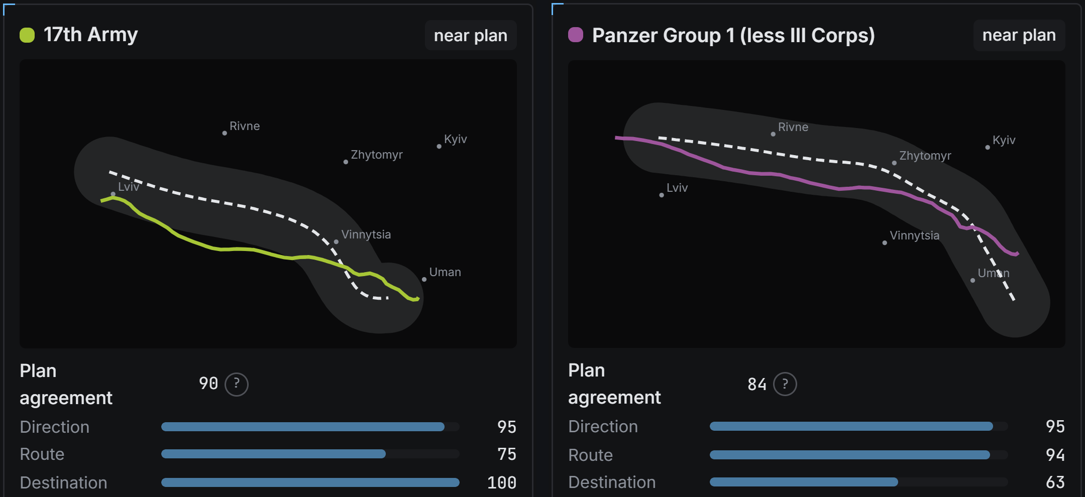
Figure 1a. Dashboard view, 17th Army and Panzer Group 1: each planned line (dashed) and the route its divisions took (solid), with the agreement scores.
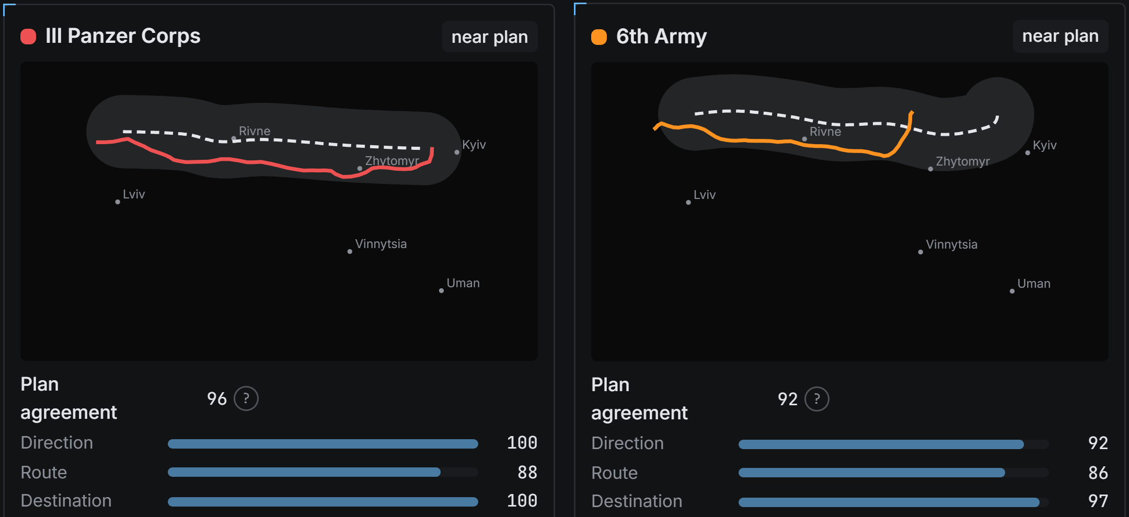
Figure 1b. The same for III Panzer Corps and 6th Army.
Planned line | Direction | Route | Destination | Overall | Reading
17th Army | 95 | 75 | 100 | 90 | right direction and end point, different route
Panzer Group 1 (less III Corps) | 95 | 94 | 63 | 84 | on route, but missed the end point
III Panzer Corps | 100 | 88 | 100 | 96 | as planned
6th Army | 92 | 86 | 97 | 92 | as planned overall, but bent north on the way
In depth, between two phase lines only:
Stretch | Heading vs plan | Direction | Average gap | End gap
6th Army, phases 2-3 | 38° further north | 18 | 26 km | 24 km
III Panzer Corps, phases 3-4 | 12° further north | 82 | 28 km | 20 km

2. Did the divisions reach each phase line on time?
Share of divisions past each phase line, or within 10 km of it, on its planned date.
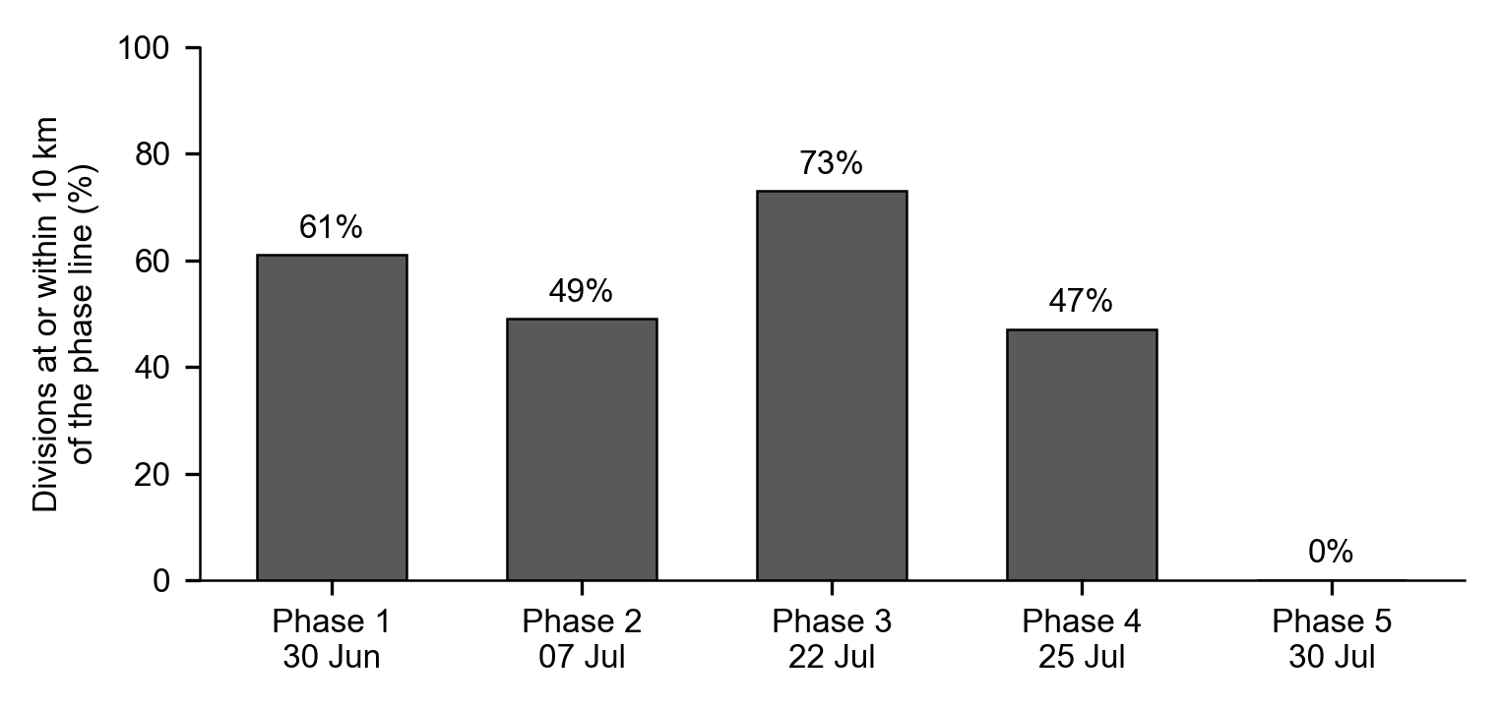
Figure 2. Arrival at each phase line on its planned date.
- Phases 1-3 were reached by about half to three quarters of the divisions on time (61%, 49%, 73%); phase 4 by 47%; phase 5 by none.
- Dates for phases 3-5 are our reading of vague planning dates: 22 July for 'mid-July', 25 July for 'after mid-July', 30 July for 'late July'.

3. How were the divisions spread around each line?
On each planned date, every division is placed along the general direction of the advance; Jenks natural breaks cut that line where the divisions clump; only then is each group read against the phase line: all past (every division in it had crossed), partly past (some had) or none past.
Phase (date) | 10 km rule | Groups | In all-past groups | In partly-past groups | In none-past groups
1 (30 Jun) | 61% | 5 | 8% (3 div.) | 62% | 30%
2 (07 Jul) | 49% | 4 | 36% (15 div.) | 26% | 38%
3 (22 Jul) | 73% | 4 | 27% (13 div.) | 65% | 8%
4 (25 Jul) | 47% | 4 | 0% (0 div.) | 86% | 14%
5 (30 Jul) | 0% | 4 | 0% (0 div.) | 0% | 100%
- The 10 km rule makes phases 1-4 look roughly half met or better; the natural breaks show they were met loosely. Only a front group was all past the line, and most divisions sat in groups only partly past it.
- The phase lines run at an angle to the advance, so a group can be partly past a line, with its southern divisions past it and its northern ones short.
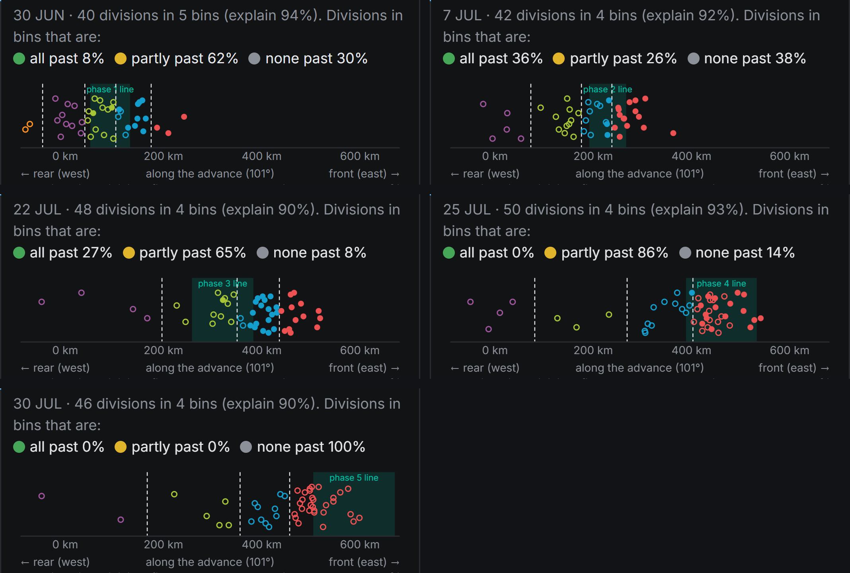
Figure 3. Dashboard view, phases 1-5 on their planned dates. Left to right: distance along the advance (west to east). Each circle is a division: filled = past the phase line, open = short of it; colour = group (red = front); dashed = natural breaks; teal band = where the slanted phase line falls on this axis.
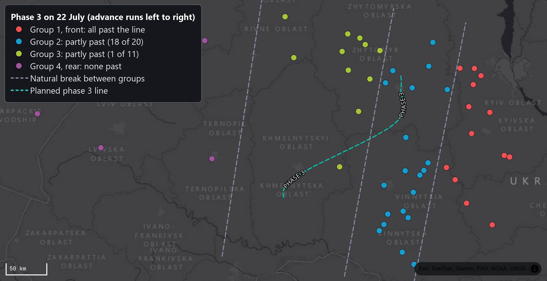
Figure 4. Dashboard view, phase 3 on 22 July: each dot is a division, coloured by its natural-breaks group (key on the map).

4. Who fought together from phase to phase?
At each phase line, divisions that crossed it close together in place and time form a fighting group. The chart follows those groups from line to line (the dashboard chart, as is).
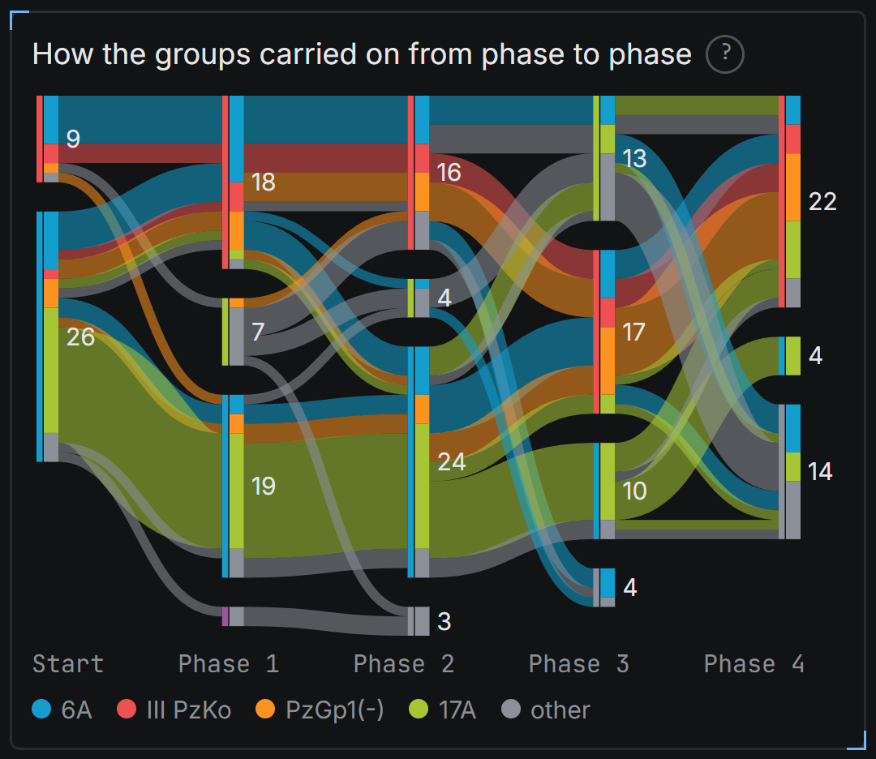
Figure 5. Blocks: fighting groups at each line (number = divisions), split by army; bands: where their divisions went next. Grey blocks: did not reach the next line by 5 August.
- They fought as two to three groups at each line (III Panzer Corps merged with Panzer Group 1), with an occasional small fourth.
- How mixed each group of 5+ divisions was (0 = one army on its own, 1 = all four mixed; unidentified divisions left out): phase 1: northern (18 div.) 0.8, south-central (19 div.) 0.5, north-central (7 div.) 0.0; phase 2: northern (16 div.) 0.8, southern (24 div.) 0.7; phase 3: central (17 div.) 0.9, southern (10 div.) 0.0, northern (13 div.) 0.5; phase 4: northern (22 div.) 0.9.

5. Also explored: local groups, day by day
Beyond what we discussed: on every day, divisions within 30 km of each other (directly or through neighbours) form a local group, and the groups are followed from day to day. Most lasted only a few days; the 17th Army group held together for all 45 days, and 6th Army, panzer and mixed groups formed in July.
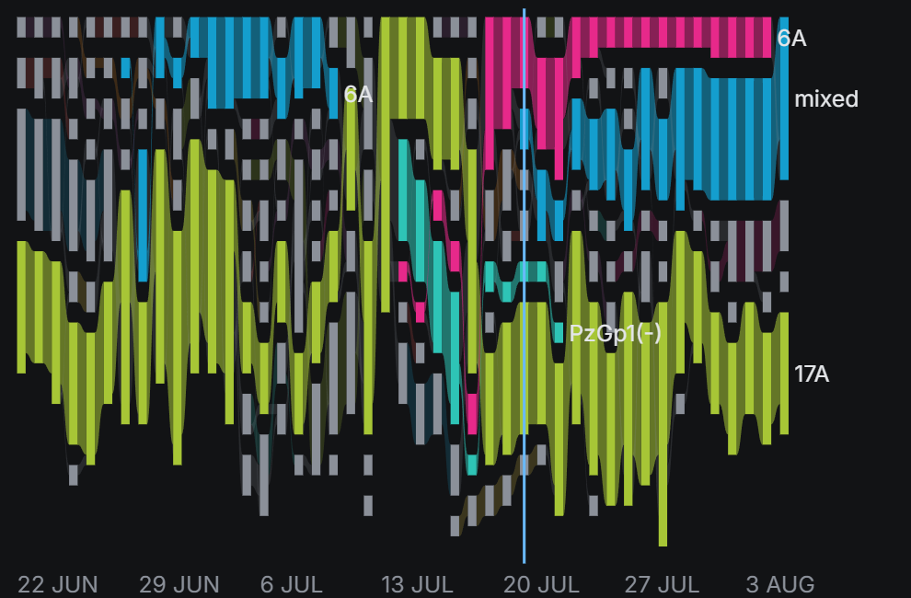
Figure 6. Dashboard view: local groups day by day; strong colours: groups that held together 10 days or more.
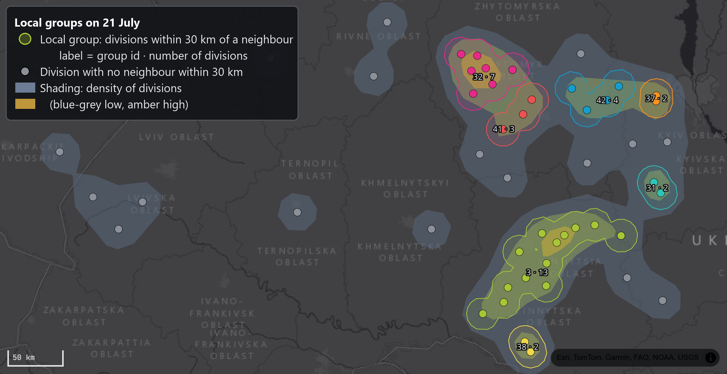
Figure 7. Dashboard view, 21 July: local groups (outlined) on the density of divisions (shading).

6. What we have done so far
- Digitized and cleaned daily division positions for four theaters; built the interactive dashboard (Barbarossa.html).
- The four analyses above: plan vs actual lines of operation, arrival at the phase lines, natural breaks around each line, and fighting groups from phase to phase.
- Black-and-white posture-over-time charts for the four theaters, for the paper.

